Military Technical College (16)
Department of Computers Engineering and AI (16)


(logo 50 height x 53.5 width – using logo with hard cover)

Project Title (18 Bold)
By (16)
Full name (16 Bold)
Military Technical College (14 Italic)

Under supervision of (16 Bold)
Supervisor rank and name (14 Bold)
Supervisor affiliation (14 Italic)

Supervisor rank and name (14 Bold)
Supervisor affiliation (14 Italic)

This project is submitted in partial fulfillment of the requirements for the degree of
Professional Diploma in Applied AI and Data Analytics (12 Bold)

Cairo 2026 (12 Bold and write the current year)
Military Technical College (16)
Department of Computers Engineering and AI (16)


(logo 50 height x 53.5 width)

Project Title (18 Bold)
By (16)
Full name (16 Bold)
Military Technical College (14 Italic)

Under supervision of (16 Bold)
Supervisor rank and name (14 Bold)
Supervisor affiliation (14 Italic)

Supervisor rank and name (14 Bold)
Supervisor affiliation (14 Italic)

This project is submitted in partial fulfillment of the requirements for the degree of
Professional Diploma in Applied AI and Data Analytics (12 Bold)

Cairo 2026 (12 Bold and write the current year)

Abstract
In the main body of the abstract, use the same spacing you use throughout the rest of your document (either double spacing or 1.5 line spacing).

Keep the section break below to allow Chapter 1 to start page 1.

Acknowledgments (16 Bold)
This page is optional. If you are not including acknowledgements, delete this page. If you are acknowledging only one person, change the title to Acknowledgment.

All body text will be written in times new roman 12 1.5 line spacing

Table of Contents
In order to generate a “Table of Contents” easily, you will need to use heading style in the above
If you use landscape pages, make sure the landscape page numbers match what is listed in your List of Tables.

Contents
Abstract I
Acknowledgments II
Contents III
List of Figures IV
List of Tables V
Nomenclature VI
Chapter (1) 1
Introduction (16 Bold) 1
1.1 The Basics 1
1.2 Margins 1
1.3 Heading Styles 1
1.3.1 Inserting a Table of Contents 1
1.4 Notes 2
1.5 Page Numbers 3
1.6 Issues with Pagination 3
Chapter (2) 4
1.7 Landscape Page 4
References 5
1.8 References Tips 5
Publications 6
1.9 Optional Section 6
Appendix (A) 7

List of Figures

Fig. No. | Title | Page No.
3.1 Space System Error! Bookmark not defined.
3.2 Control Ground Segment Configuration Error! Bookmark not defined.
3.3 Satellite Simulator Error! Bookmark not defined.
3.4 Spacecraft configuration Error! Bookmark not defined.
4.1 PCA Projection Error! Bookmark not defined.
4.2 PCA derivation Error! Bookmark not defined.
4.3 Quality of fit and prediction Error! Bookmark not defined.
5.1 Propulsion System Types Error! Bookmark not defined.
5.2 Propulsion System Layout Error! Bookmark not defined.
5.3 Unprocessed data Error! Bookmark not defined.
6-23 Analysis of Sliding window N¹⁰ for incorporated state vector-error Error! Bookmark not defined.

In order to generate a List of Figures easily, you will need to assign a caption to all of the figures in your document. After this has happened, click on the References Ribbon, select Insert Table of Figures, under general select Table from drop down box, select OK. Be sure to indent subsequent lines of captions.

If you use landscape pages, make sure the landscape page numbers match what is listed in your List of Tables.

List of Tables

Table No. | Title | Page No.
‎5.1 Effective parameters Error! Bookmark not defined.
‎6.1 VNN Summary Error! Bookmark not defined.
‎6.2 LSTM Summary Error! Bookmark not defined.
‎6.3 CNN Summary Error! Bookmark not defined.
‎6.4 Time computation comparison Error! Bookmark not defined.

In order to generate a List of Tables easily, you will need to assign a caption to all of the tables in your document. After this has happened, click on the References Ribbon, select Insert Table or Figures, under general select Table from drop down box, select OK. Be sure to indent subsequent lines of captions.

If you use landscape pages, make sure the landscape page numbers match what is listed in your List of Tables.

Nomenclature
Abbreviations
ANN Artificial Neural Networks
ACS Attitude Control System
BN Bayesian network
CS Communication Session
CNN Convolutional Neural Network
EMA Electro-Magnetic Actuator
EMD Empirical Mode Composition
ESA European Space Agency

This is optional section. If you do not have a Glossary, List of Abbreviations, List of Symbols, or Nomenclature section, delete this page.
If you are using this page, choose one of the headings above. Entries should be spaced consistently (single line spacing, 1.5 line spacing when applied consistently).

Symbols

Abbreviations

Chapter (1)

Introduction (16 Bold)

The Basics
This template is best used with MS Office 2013 or Later. It is suggested to turn on the Show/Hide tool (¶) that can be found on the Home ribbon so you can track you spacing and section breaks.

Review the Template Guide before you begin. Use it for troubleshooting. If you can’t find a solution there, try Microsoft’s extensive help pages.

Margins
Margin requirements are 2.5 cm left and top whereas right and bottom margins are 1.5 cm. margins are required on Title and Statement of Approval pages. 2.5 cm left margin is recommended for a hard copy.

Heading Styles
There are many heading styles that have been added to the Styles Ribbon. There are Chapter Headings 1 and 2 in the style ribbon. You will have to use heading 1 for sections and heading 2 for subsections. You will want to use these styles so you can generate a table of contents without any issues. If you open the navigation toolbar [Ctrl + F] and under the search document bar you choose “Headings” you will be able to easily track which headings will go in your table of contents.

If after you apply a Style to a heading and you receive Error! Bookmark not defined in your Table of Contents after updating the page number, go back to your heading that is causing the issue and make sure there is still a style applied to it. You can update the entire table to resolve the issue – if you had previously formatted the Table of Contents, you may have to re-format.

Inserting a Table of Contents
In order to insert an automatic table of contents, you will have needed to apply styles to your headings (as shown above). Once your headings have been assigned a style, you can then insert a table of contents that will automatically populate with the correct heading level indentations, leader dots, and page numbers. This will also create an embedded link from your table of contents to the section in your project in both a MS Word doc and in a PDF file.
To insert the table, follow these instructions:
- In Ribbon above, click References
- Click ‘Table of Contents’ on the left hand side of the ribbon
- Choose ‘Custom Table of Contents’ below the built-in tables
- After a Table of Contents box pops up, click “OK”, without making any changes within the box.
Typically, inserting a table of contents, list of figures, and list of figures should be the last step in the formatting practice. If you’ve made changes to content that moves a heading to a different page number, all you’ll need to do is go back to your inserted table of contents, right click, select ‘Update Field’, and select “Update page numbers only”. This will make changes to your page numbers and won’t affect the headings.

To create a table of contents you will need to assign a heading style to each heading in your entire document then follow the steps below:
- Locate your Table of Contents page above
- In the Ribbon above, click References
- In the Table of Contents section, click Table of Contents
- Look past the built-in Table of Contents and select Insert Table of Contents
- Under the General section in the Show Levels box, select the number of headings you want to show in the Table of contents – 3 levels are common, but it can incorporate all levels, if you wish.

Notes
If you are planning to include List of Figures and List of Tables, we recommend you using the following method to insert your captions:
- In Ribbon above, click References
- In Captions section, click on Insert Caption
- Next to Label, chose Table or Figure
- Click OK
- Type your caption next to the table/figure number.

Page Numbers
Page numbers will go in the lower middle of each portrait page, chapter (1) will begin with page (1) whereas the previous pages are numbered with Latin numbers. If you are using any landscape orientation pages, the page number will go in the lower middle with vertical text. Page number font and font size needs to be the same as the main body text.

Issues with Pagination
Occasionally, page numbers will overlap due to section breaks. To fix this issue, simply click on the page number and locate the Design ribbon at the top of the page. Click the drop down arrow on page number > Format page numbers > under the Page numbering section choose Continue from previous section.

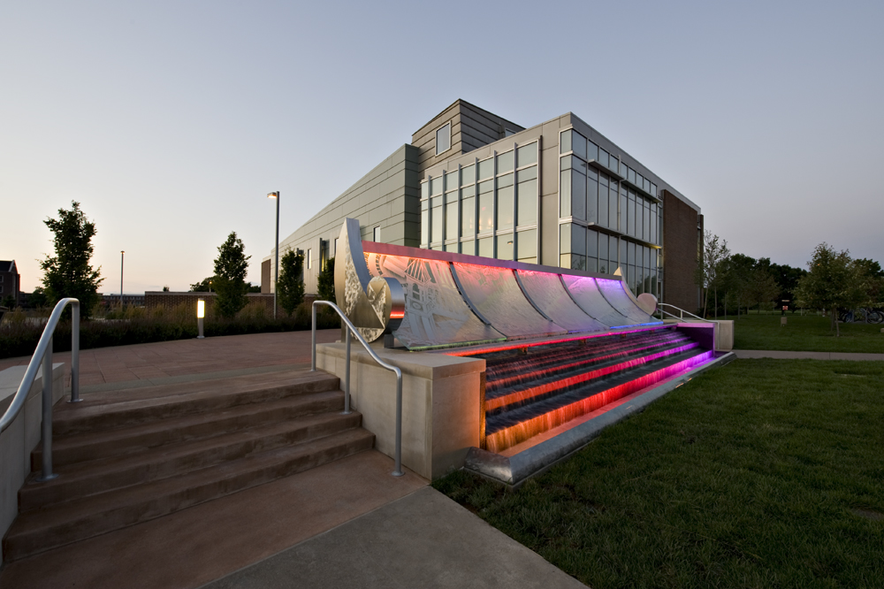
Fig. (1.1) The main building (12 Bold)

Chapter (2)

Landscape Page
You may use landscaped pages for large tables or figures that normally will not fit within left and right margins. Note that page numbers will need to be added manually with a text box (that is in place in the bottom middle). A normal page number will show up in the lower middle when adding pagination. You will need to unlink this page and the next page’s pagination to previous in order to keep the pagination in the correct place. Use the page number text box in the lower middle of this page for additional landscape pages.

To achieve adding a landscape page, you will need to add a Next Page section break on the previous page. You will also need to add a Next Page section break to the end of this page to convert back to a portriat orientation. It is beneficial to open the Show/Hide control on the Home Ribbon in the Paragraph section so you can see where all extra spacing is and where section and page breaks are.

References

References Tips
Include reference entries here using the (IEEE) format. References will be put in square bracket as it appears in the body text.

- Yang, Lei, Pengqi Yu, and Hang Tang. "Real-Time Failure Diagnosis Technology for Satellites Based on Multi-Signal Model." In Computational Intelligence and Design (ISCID), 2014 Seventh International Symposium on, vol. 1, pp. 360-364. IEEE, 2014.

Publications

Optional Section

This is where you can place a list of publication or alternately, you can include a PDF of a published article. This article may either be in color or black and white.

All pages of publications need page numbers sequential to the number in the rest of your project. You may need to block out original page numbers to prevent confusion. If you have only one publication, list the title as PUBLICATION.

Appendix (A)
If you have large tables or figures to include, we ask that you use landscape pages and place the Appendix Title above the figure/table.

Table (‎0.1) (12 Bold)

ملخص المشروع

الكلية الفنية العسكرية
قسم هندسة الحواسب والذكاء الإصطناعى

اسم المشروع باللغة العربية

مشروع مقدم من

للحصول على الدبلوم المهنى فى
تحليل البيانات والذكاء الاصطناعى التطبيقى

تحت إشراف
عميد أستاذ دكتور/ طارق غنيمى الجهه

الكلية الفنية العسكرية

القاهرة 2026

